Medical perspectives on 741/ 555 (Female Basketball players)
Partnered with Gemini

1. Clinical Profile: Player 741 (Women's Basketball)
Diagnosis: "High-Force / Low-Efficiency Strategy" or "The Force-Dominant / Mechanically Inefficient Athlete"
Dashboard Evidence:
- Jump Height: 0.27m (Low)
- Peak Power: 3627 W (High — higher than Player 555)Above team average (3483 W). She produces high raw force.
- mRSI: 0.36 (Very Low — Red Flag)
- Variability (CV): 23.5% (High — Inconsistent)
Anatomical Analysis:
Muscle-Driven Strategy: Player 741 generates significant force (High Power) but fails to translate it into height. The low mRSI indicates a "soft" muscle-tendon unit. She likely relies heavily on Quadriceps and Glutes (concentric strength) rather than the elastic recoil of the Achilles Tendon.
Injury Risk: ACL & Patellofemoral Pain
Because she lacks "stiffness" (low mRSI) and has high variability (23.5%), her knees are unstable during landing. When she fatigues, she is prone to Dynamic Knee Valgus—where the knees cave inward. This is the #1 mechanism for non-contact ACL tears in female basketball players.

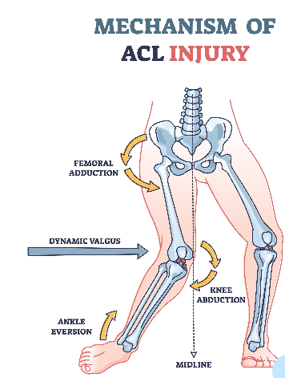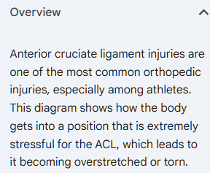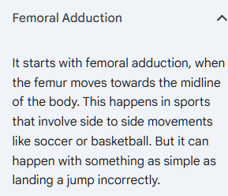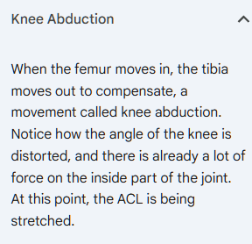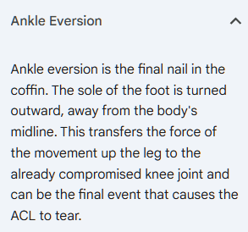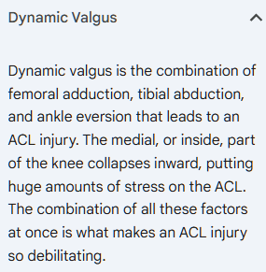

Injury Risk Assessment
- Patellofemoral Pain Syndrome (Runner’s Knee):
  - Mechanism: Her deep knee flexion strategy (implied by low mRSI) increases compressive forces on the patellofemoral joint. The quadriceps are working overtime to decelerate her body mass.
  - Risk Level: HIGH.
- ACL Injury Risk:
  - Mechanism: "Muscle-dominant" jumpers often fatigue faster than "tendon-dominant" jumpers. Under fatigue, neuromuscular control degrades, leading to dynamic valgus (knees caving in) during landing.
  - Risk Level: MODERATE-HIGH (especially if asymmetry >10% is noted on the dashboard).

Medical Recommendations
- Training Focus: Stiffness & Eccentric Control. She needs to learn how to "hit and go" (plyometrics) to shift the load from her knee joint to her ankle complex.
- Clinical Monitor: Watch for anterior knee pain or "heaviness" in the legs, which precedes overuse injuries in this profile.

2. Clinical Profile: Player 555 (Women's Basketball)
Diagnosis: "Elastic / High-Velocity Strategy"
Dashboard Evidence:
- Jump Height: 0.31m (Above Average)
- Peak Power: 3529 W (Moderate)
- mRSI: 0.52 (Elite — Green Flag)
- Variability (CV): 5.2% (Very Low — Highly Consistent)
Anatomical Analysis:
Player 555 is a "Tendon-Dominant" athlete. Even though she produces less raw power than Player 741, she jumps higher. Why? Her mRSI (0.52) indicates she uses her Achilles Tendon like a stiff spring, recycling energy efficiently without deep knee bends. Player 555 is a "stiff spring." She utilizes the Stretch-Shortening Cycle (SSC) effectively. Her Achilles tendons and plantar fascia act as efficient springs, recycling energy during jumps.

Injury Risk Assessment
- Achilles Tendinopathy:
  - Mechanism: While efficient, her reliance on tendon elasticity places high tensile loads on the Achilles. High-velocity movements (high mRSI) create rapid loading rates that can cause micro-tears if recovery is insufficient.
  - Risk Level: MODERATE (Volume-dependent).
- Hamstring Strain:
  - Mechanism: Her high Peak Velocity (2.60 m/s) means her hamstrings must contract rapidly to decelerate the leg during landing or sprinting. If eccentric hamstring strength is lacking, the muscle fibers can tear under high-velocity tension.
  - Risk Level: MODERATE (during sprints).

Medical Recommendations
- Training Focus: Load Management. Her mechanics are good, so the goal is preservation. Monitor her Total Distance (from the dashboard/Kinexon). If distance spikes >20% in a week, her Achilles risk skyrockets.
- Clinical Monitor: Daily checks for morning stiffness in the Achilles or calf tightness.

3. Summary Comparison Table

Feature | Player 741 (At-Risk) | Player 555 (Optimal) | Clinical Implication
Primary Driver | Muscles (Quads/Glutes) | Tendons (Achilles/Calf) | P741 is "Grinding"; P555 is "Bouncing".
mRSI Status | 0.36 (Low/Red Flag) | 0.52 (High/Green) | Low mRSI = Poor shock absorption = Joint Stress.
Injury Profile | Knee Joint (ACL, Meniscus, Patella) | Soft Tissue (Achilles, Hamstring) | P741 needs mechanics coaching; P555 needs volume control.
Fatigue Sign | Drop in Jump Height (loss of power) | Drop in mRSI (loss of spring) | P555 will "look" normal but lose stiffness (ground contact time increases).

Final Recommendation:
Prioritize Player 741 for neuromuscular retraining. Her high power output (3627 W) combined with poor control (23.5% variability) is a recipe for a season-ending knee injury if not corrected.

